|  |  |  |  |  |  |  |  |  |  |  |  |  |  |  |  |  |  |  |  |  |  |  |  |  |  |  |
| --- | --- | --- | --- | --- | --- | --- | --- | --- | --- | --- | --- | --- | --- | --- | --- | --- | --- | --- | --- | --- | --- | --- | --- | --- | --- | --- |
| **FORMULIR AKUISISI PROPERTI LANDED HOUSE – MNC Play** | | | | | | | | | | | | | | | | | | | | | | | | | | |
| Nama Properti | | |  | | | | | | | | | | | | | | | | | | | | | | | |
| Nama Perusahaan/Pengelola | | |  | | | | | | | | | | | | | | | | | | | | | | | |
| Alamat | | | RT. RW. Kec.  Kel. Wil. Kota | | | | | | | | | | | | | | | | | | | | | | | |
| Koordinat | | |  | | | | | | | | | | | | | | | | | | | | | | | |
| Status Bangunan | | | Under Developer Non Developer | | | | | | | | | | | | | | | | | | | | | | | |
| Clustering/ Under BM Open Area/Tanpa Pengelola | | | | | | | | | | | | | | | | | | | | | | | |
| Existing / Sdh Terbangun | | | | | | | | | | | | | | | | | Launch DD/MM/YY : | | | | | | |
| On Progress/Dlm Pembangunan | | | | | | | | | | | | | | | | |
| Average Harga Unit | | | Terendah, Rp. Tertinggi, Rp. | | | | | | | | | | | | | | | | | | | | | | | |
| Jumlah Cluster atau Blok | | | 1 | | | | | 2 | | | 3 | | | 4 | | | 5 | | 6 | | | Keterangan | | | | |
| Jumlah Unit | | |  | | | | |  | | |  | | |  | | |  | |  | | |  | | | | |
| Jumlah Unit Terisi | | |  | | | | |  | | |  | | |  | | |  | |  | | |  | | | | |
| Tingkat Okupansi | | |  | | | | |  | | |  | | |  | | |  | |  | | |  | | | | |
| Average Harga Unit | | | Terendah, Rp. Tertinggi, Rp. | | | | | | | | | | | | | | | | | | | | | | | |
| Infrastruktur Yang Ada | | | Coaxial FTTH ADSL UTP Belum ada | | | | | | | | | | | | | | | | | | | | | | | |
| Metode Pembangunan Infrastruktur | | | KU – Kabel Udara (*Pasang Tiang/Clamp Wall/Ceilling*) | | | | | | | | | | | | | | | | | | | | | | | |
| UG – Under Ground (*Bawah Tanah/Suwer – Saluran Air*) | | | | | | | | | | | | | | | | | | | | | | | |
| Mixed KU (*Kabel Udara*) – UG (*Under Ground*) | | | | | | | | | | | | | | | | | | | | | | | |
| Pembangunan Infrastruktur s/d. | | | ODP/FAT Unit (TB) | | | | | | | | | | | | | | | | | | | | | | | |
| Internet Service | | | Dedicated Broadband | | | | | | | | | | | | | | | | | | | | | | | |
| Layanan yang disediakan MNC | | | Internet IPTV Telephony* | | | | | | | | | | | | | | | | | | | | | | | |
| **Profile Penghuni** | | | | | | | | | | | | | | | | | | | | | | | | | | |
| Status Penghuni | | | | | Single ( %) Pasangan Muda ( %) Usia > 45 Thn ( %) | | | | | | | | | | | | | | | | | | | | | |
| Jenis Pekerjaan | | | | | Mahasiswa ( %) Karyawan ( %) Pengusaha ( %) | | | | | | | | | | | | | | | | | | | | | |
| Pengelola berkenan untuk membantu penjualan? Ya Tidak | | | | | | | | | | | | | | | | | | | | | | | | | | |
| **Provider Existing** | | | | **Berikan tanda cek list** | | | | | | | | **Eksklusif** | | | | | | **Durasi Kerjasama s/d. Bln/Thn** | | | | | | **Skema Kerjasama** | | |
| **Inet** | | | **TV** | | | **Telp.** | | **Y** | | | **N** | | |
| 1. |  | | |  | | |  | | |  | |  | | |  | | |  | | | | | |  | | |
| 2. |  | | |  | | |  | | |  | |  | | |  | | |  | | | | | |  | | |
| 3. |  | | |  | | |  | | |  | |  | | |  | | |  | | | | | |  | | |
| 4. |  | | |  | | |  | | |  | |  | | |  | | |  | | | | | |  | | |
| 5. |  | | |  | | |  | | |  | |  | | |  | | |  | | | | | |  | | |
| **Skema Kerjasama Dengan MNC Play** | | | | | | | | | | | | | | | | | | | | | | | | | | |
| Status Kerjasama/ Periode | | | | Exclusive Non Exclusive Thn | | | | | | | | | | | | | | | | | | | | | | |
| **Aktifitas Sales & Marketing Tools** | | | | | | | | | | | | | | | | | | | | | | | | | | |
| Penempatan/ Pemasangan/  Penyebaran Marketing Tools | | **Lapangan Olah Raga** | | | | | | | **Kantor Pemasaran** | | | | **Club House** | | | | | | | **Diseluruh**  **Area Cluster** | | | **Area Taman/**  **Play Ground** | | **Pintu Gerbang**  **Cluster** | **Tempat Ibadah** |
| **Kolam Renang** | | | **Fitness Center** | | | |
| Aktifitas Sales Probing/  Door to Door | |  | | | | | | |  | | | |  | | |  | | | |  | | |  | |  |  |
| Penempatan Spanduk (*terlampir*) | |  | | | | | | |  | | | |  | | |  | | | |  | | |  | |  |  |
| Penempatan Poster (*terlampir*) | |  | | | | | | |  | | | |  | | |  | | | |  | | |  | |  |  |
| Experience Car (*terlampir*) | |  | | | | | | |  | | | |  | | |  | | | |  | | |  | |  |  |
| X/Roll Up Banner (*terlampir*) | |  | | | | | | |  | | | |  | | |  | | | |  | | |  | |  |  |
| Acrilic Box /Brosur (*terlampir*) | |  | | | | | | |  | | | |  | | |  | | | |  | | |  | |  |  |
| Catatan; | | | | | | | | | | | | | | | | | | | | | | | | | | |
| Saya yang bertandatangan menyatakan bahwa informasi ini adalah benar adanya, untuk kebutuhan follow up kerjasama yang cepat secara detail dan akurat. | | | | | | MNC Play  (..................................................)  Jabatan: | | | | | | | | | | | | | | | Pihak Mitra  Tgl.  (..................................................)  Jabatan:  No.Telp.  No.HP. | | | | | |

|  |  |
| --- | --- |
| Catatan dan Rekomendasi Sales Kadept./ Kadiv.  Rekomendasi : REJECT DROP APPROVE | Jakarta, _____________________  (..................................................)  Jabatan: |

* Optional | Catatan: Beri tanda Cek (√) pada kolom pilihan dan coret yang tidak perlu

REJECT : Proyek tidak direkomendasikan secara permanen

DROP : Proyek tidak direkomendasikan namun dapat di follow up kembali

APPROVE : Proyek disetujui dan dapat dilanjutkan

**POSTER**

*Ukuran 118,9 cm x 84,1 cm*

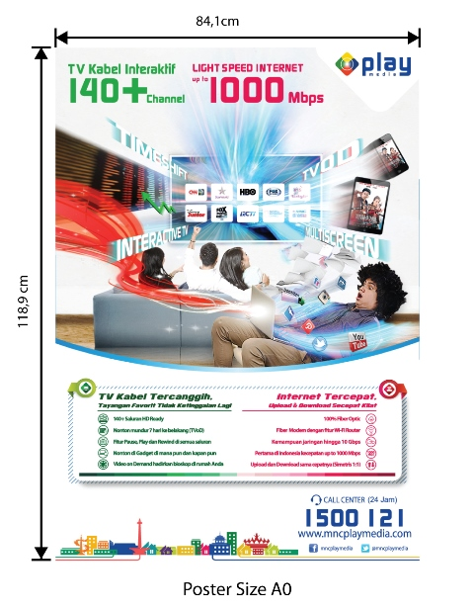

**ACRILIC BOX /Brosur**

*Ukuran 20 cm x 30 cm x 5 cm*

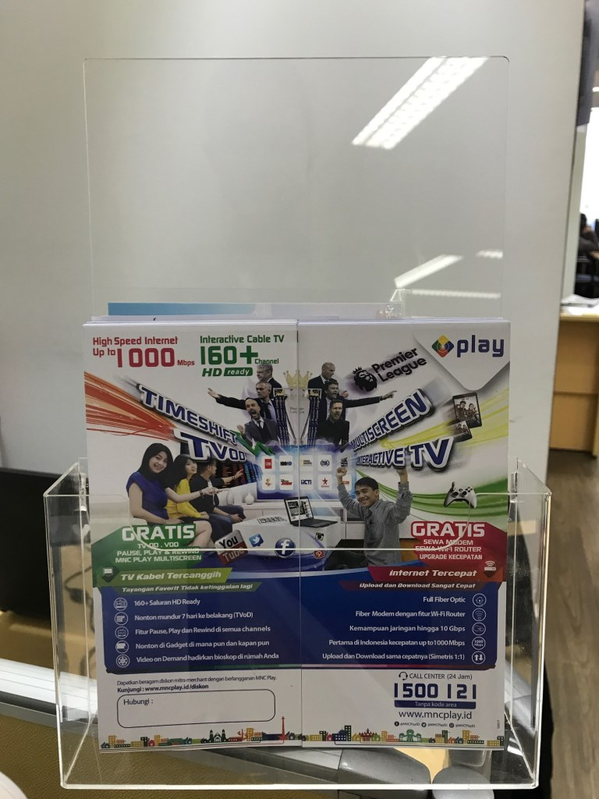

**POP UP TABLE**

*Ukuran 184 cm x 90 cm*

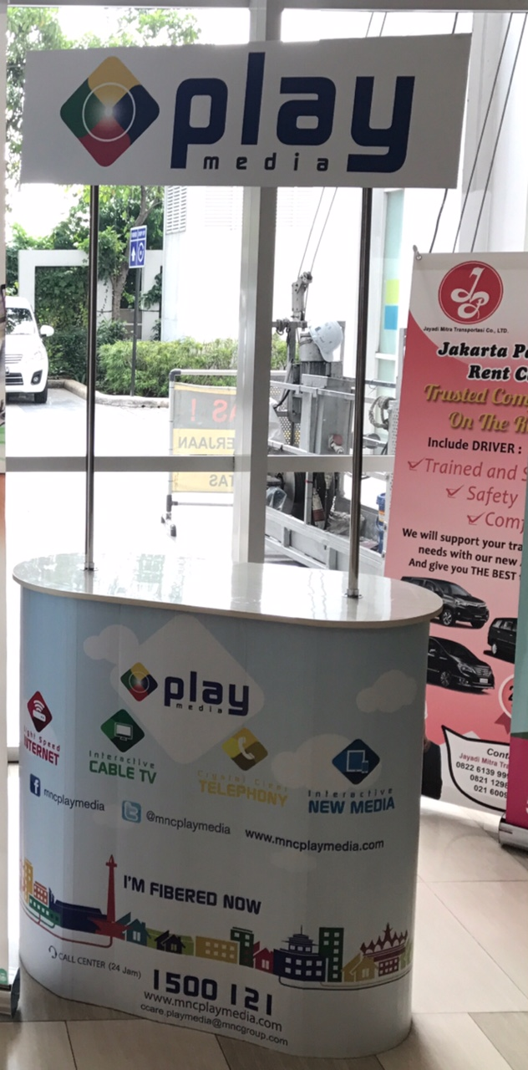

**X/ROLL UP BANNER**

*Ukuran 200 cm x 80 cm*

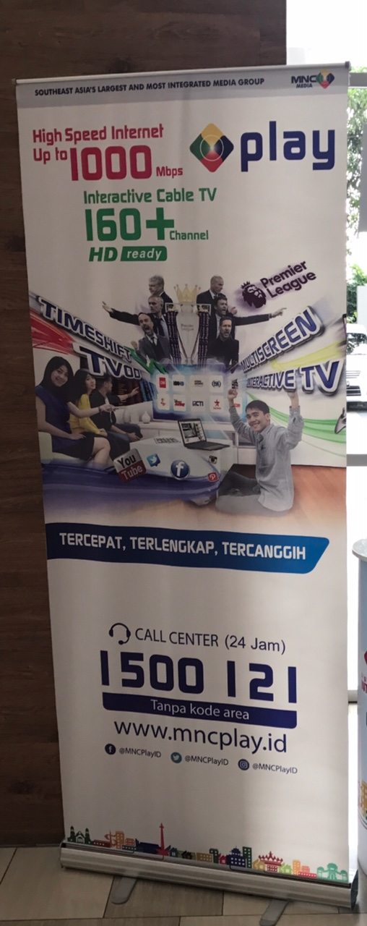

**SPANDUK**

*(ukuran 2 x 4 m / disesuaikan)*

**EXPERIENCE CAR**

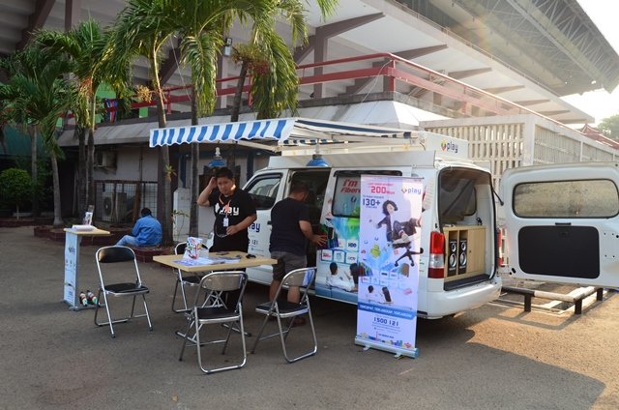

*Catatan:*

*Design, content atau redaksi serta ukuran pada material marketing tools diatas adalah merupakan ilustrasi semata. Design, content atau redaksi serta ukuran yang akan digunakan sebagai materi promosi akan mengikuti atau disesuaikan deng*